**Dynamics and Newton’s Law of Motion**

**ABSTRACT:** This experiment measured the Earth’s gravitational acceleration (g) by using two masses and a pulley to time how long it took for one mass to pull the other. The time is then used to calculate the gravitational acceleration g. It was measured that g=8.9 m/s^2 +/- .33 m/s^2, which is off the generally accepted value of 9.8 m/s^2.

Report written by: Tamer Avci

Lab partner: Bharath Shankar

October 10, 2013

**INTRODUCTION**: The Newton’s laws of motion are fundamental for classical mechanics. This experiment confirms the second law of motion: The acceleration of a body is directly proportional to, and in the same direction as, the net force acting on the body, and inversely proportional to its mass. Thus, F = ma, where F is the net force acting on the object, m is the mass of the object and a is the acceleration of the object.

In other words, if a net force on an object(s) is different than zero, the object(s) will accelerate in the direction of the net force. As shown below, the mass M1 will accelerate due to tension of the string T, which is caused by the net force on M2 = M2*g. Since we assume there is no friction, there is no force acting in the opposite way.

**PROCEDURE**: The air source was turned on and the air track was adjusted so that the track made no angle with respect to horizontal surface.

The mass of two M1s and M2 were weighted and written down. A string was attached between the flag and M2. Its length was adjusted accordingly. Next, the length of the flag was measured.

By using the two photogates, the time it took M1 between two photogate and the time to pass each photogate were collected through the computer software. For the following trials 20g was added until 100g in total to the M2 and the same procedure was followed. For the other M1 40g was added until 200g in total was reached.

The data was transferred to Excel. The time change and change of velocity were used to calculate the acceleration. Consequently, a graph a vs. M2/(M1+M2) was drawn.

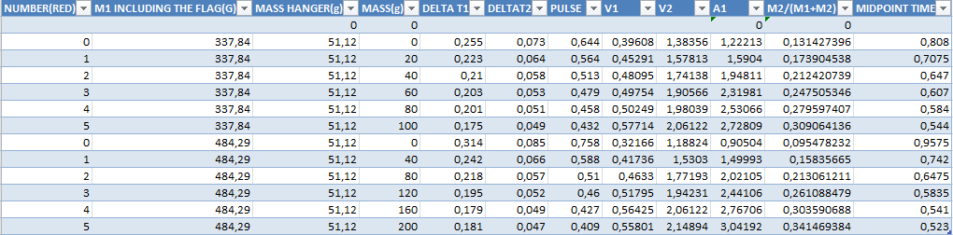

**RESULTS AND ANALYSIS**: The first and second velocity are calculated by dividing the length of flag by the time M1 passes the each photogate. Since now we have two different velocities at two different points of time, we can measure the acceleration by taking the change of velocity and the time that is spent between two points of time into account.

To get the midpoint time we do: 1/2t1 + 1/2 t2 + pulse. This gives us the time it took for M1 to increase its velocity from v1 to v2. The acceleration is therefore a = (v2-v1)/midpoint time. After calculating the acceleration a graph can be drawn regarding the data shown regarding the values in the graph. The acceleration we have calculated is in accord with the Newton 2nd law. The net force is M2*g. The total mass is M2+M1. The acceleration is therefore F/M= M2*g/(m1+m2). Hence the g value is the slope of the graph a vs m2/(m1+m2). The g value we get from this experiment is 8.91+/-.33 m/s^2.

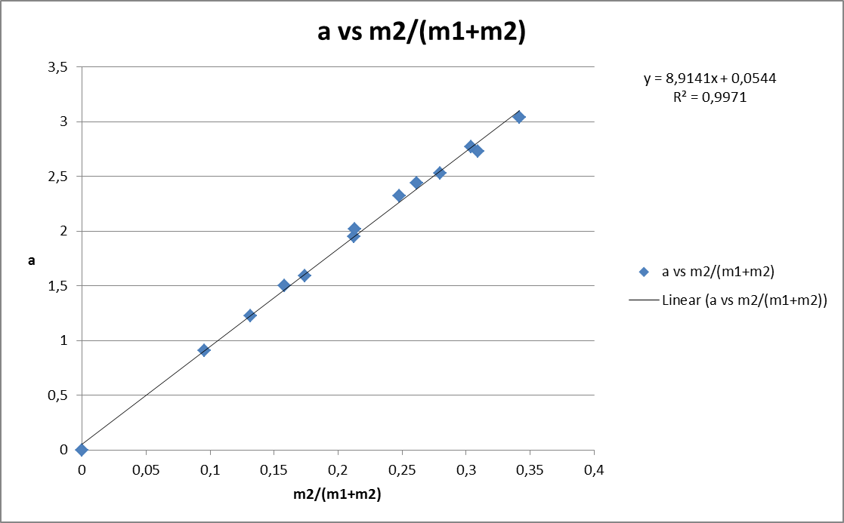

**CONCLUSION**: The measured value of g happened to be lowe that the real value of g. Several things may account for this discrepancy. However, one thing may play a significant role in this experiment: balancing the air track. Throughout the experiment, we noticed that the air track was not level. The imbalance of the track creates an angle between the horizontal direction and the direction M1 is moving, so that there is an additional force acting on M1, which is the horizontal component of gravity due to the angle. That is why the value of g might have decreased in our experiment. A more accurate measurement could be done by making sure that the track stays balanced and repeating this experiment many more times to generate more data.